VGGNet paper published in 2014, it has simple architecture which has:

1. Similar kernel:

* Size: 3\*3
* Padding: same
* Stride: 1

1. Similar Pooling layer:

* Size: 3\*3
* Stride: 2

There are 2 variants of VGG: VGG16 and VGG19

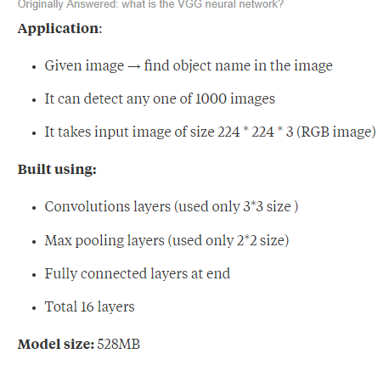 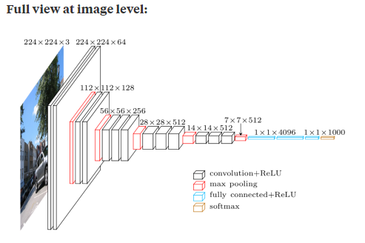

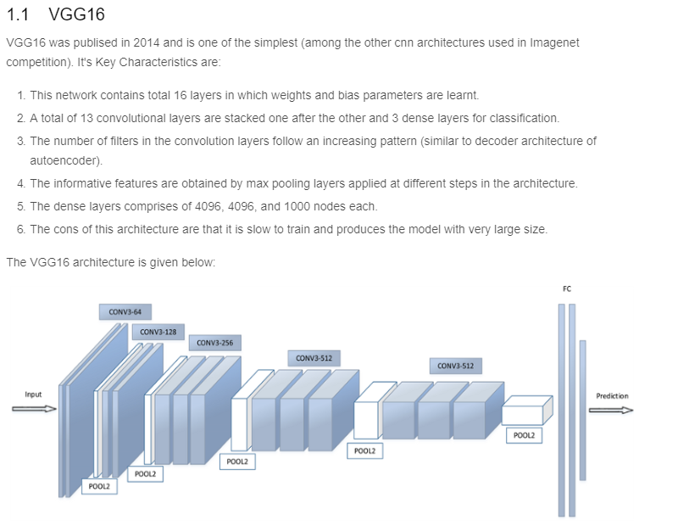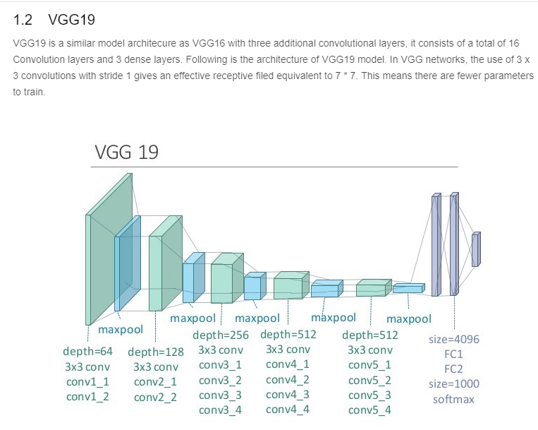

Description image:

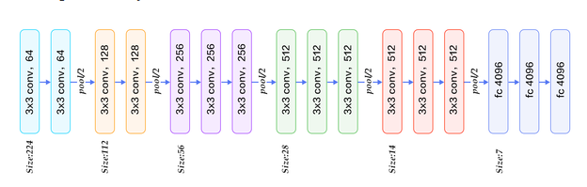

There is pre trained model provided by keras for vgg on imageNet dataset, so we don’t need to train it <https://github.com/fchollet/deep-learning-models/blob/master/vgg16.py>

<https://www.quora.com/What-is-the-VGG-neural-network>

kaggle.com/shivamb/cnn-architectures-vgg-resnet-inception-tl

how to use keras vgg pretrained model: <https://machinelearningmastery.com/use-pre-trained-vgg-model-classify-objects-photographs/>

